**ASSIGNMENTS ON DIGITAL MARKETING**

**NAME:** KEERTHIVASAN R

**DEPARTMENT:** BE COMPUTER SCIENCE AND ENGINEERING

**COLLEGE:** 8151 DHANALAKSHMI SRINIVASAN INSTITUTE OF

TECHNOLOGY

**NAANMUDHALVAN COURSE**: DIGITAL MARKETING

**NM ID:** 897F5605376E94497F844B133357D1AB

**ASSIGNMENT 1:**

Create a blog or website using Blogspot and WordPress. Customize

The theme design and post new article with 500 words.

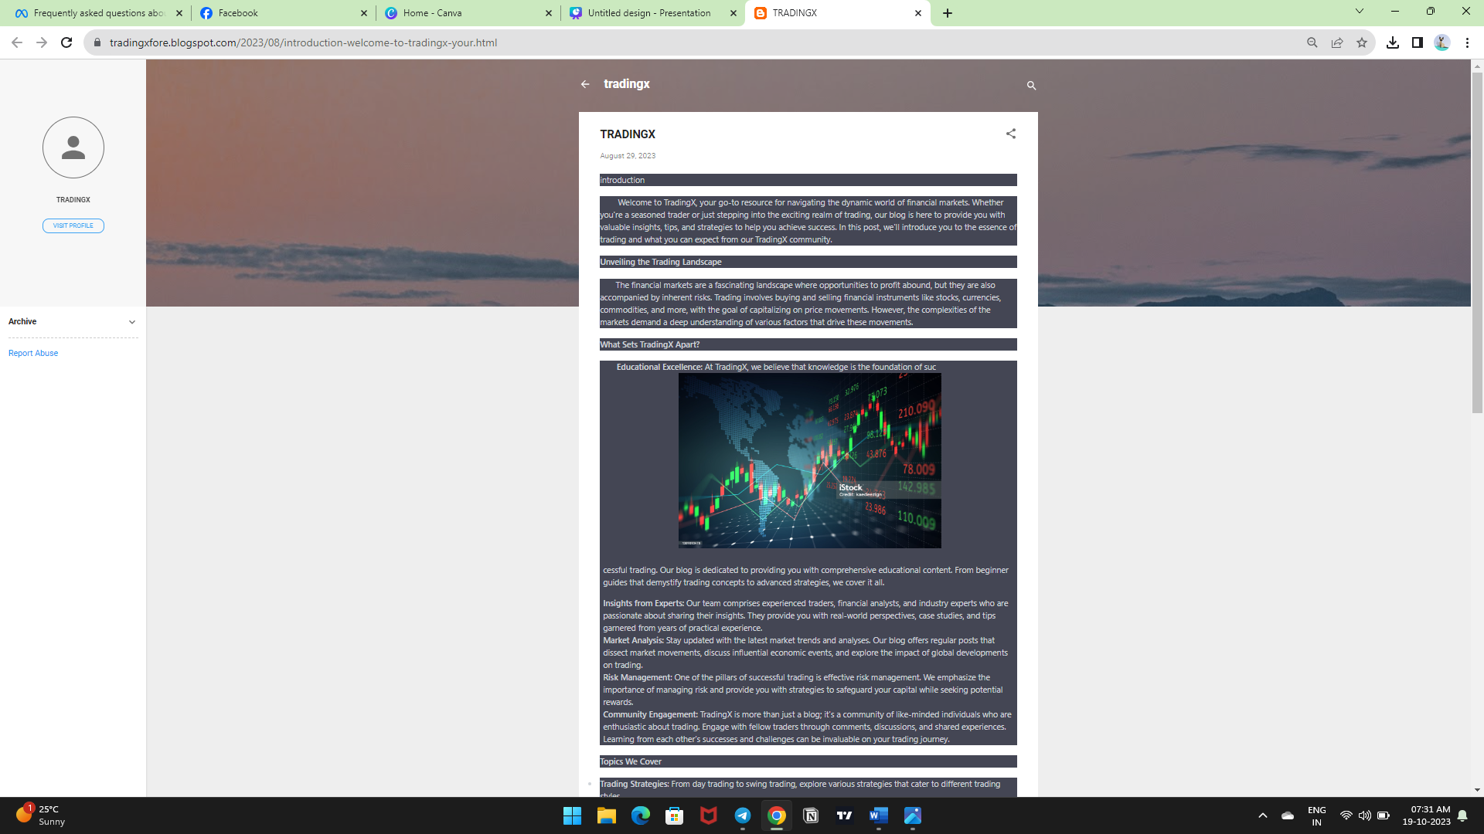 <https://tradingxfore.blogspot.com/2023/08/introduction-welcome-to-tradingx-your.html>

**ASSIGNMENT 2:**

Create a new Facebook business Page and Post one social media poster for your brand.

<https://www.facebook.com/profile.php?id=61552728231658&sk=photos>

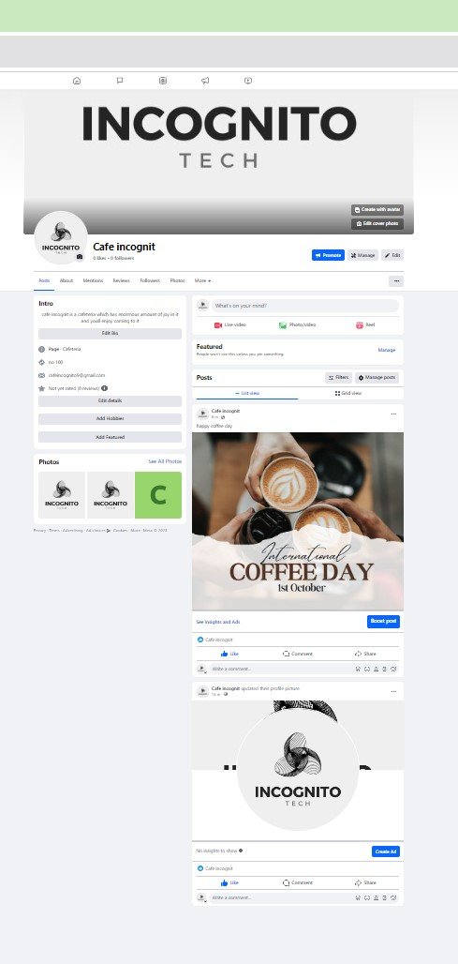

**ASSIGNMENT 3:**

Create and design a social media advertisement poster using Canva.

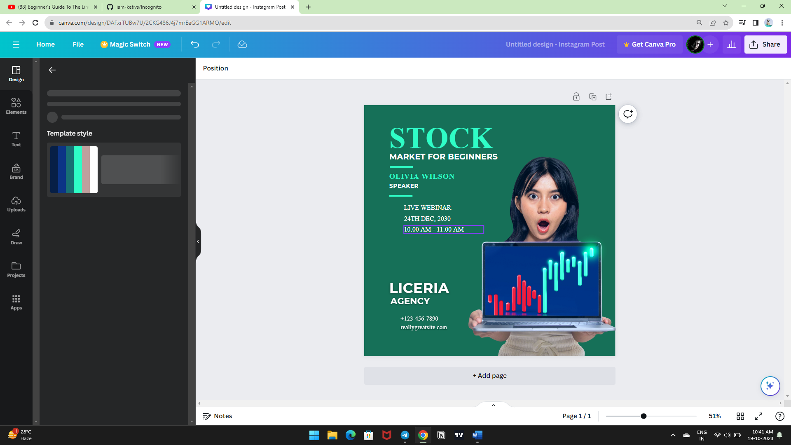

**ASSIGNMENT 4:**

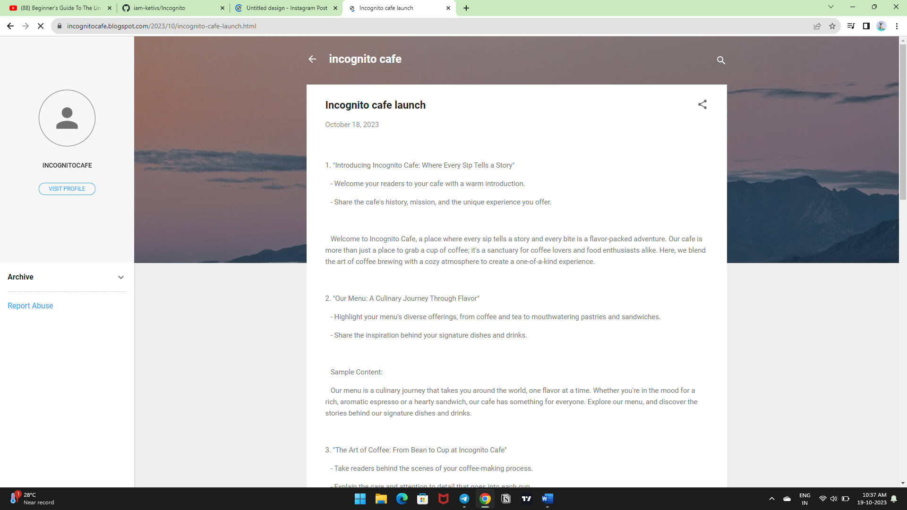4.Create email newsletter design using MailChimp or Canva tool.